TATA INSTITUTE OF SOCIAL SCIENCES
School of Public Policy and Governance
Hyderabad

Diabetes Prediction in India:
Lessons Learnt from NFHS-5
Assignment Report
Course: DSPP-3 Decision Modelling in Public Policy
Submitted by
Abhishek Anand Sinha
Roll No. H2025PPG001
MA in Public Policy and Governance
Submitted to
Dr. Pramod Kumar Mishra
Date of submission: 24 October 2026

Contents
Data and study design 3
1. Missing value treatment 3
2. Outlier treatment 4
3. Descriptive statistics 5
4. Model building (decision tree) 7
5. Cross-validation 8
6. Inferences 10
Lessons for policy 11

Data and study design
The analysis covers 770,295 adults aged 15–49 from NFHS-5 (2019–21). Of these, 9,144 (1.19%) were taking a prescribed medicine to lower blood glucose, which is the outcome the model predicts.
Three NFHS-5 files were combined in Stata. The women's file (IR, 724,115 women) and men's file (MR, 101,839 men) were appended, with a gender dummy marking the source. Men's height and weight are not stored in MR, so they were taken from the household file (HR) and matched on cluster, household and line number; all 101,839 men matched. Men were restricted to ages 15–49 to match the women's age range.
Table 1: Indicators and NFHS-5 variables used
Indicator | NFHS-5 variable (women / men) | Type
Random blood glucose (mg/dL) | sb74 / smb74 | Continuous
Systolic and diastolic BP (mm Hg) | Mean of 2nd and 3rd readings, sb25–sb29 / smb25–smb29 | Continuous
BMI (kg/m²) | v445 / hb40 (HR file) | Continuous
Hypertension | Told high BP or on BP medicine, sb20–sb21 / smb20–smb21 | Binary
Alcohol use | s720 / sm619 | Binary
Tobacco use (incl. bidis) | v463z + s708 / mv463z | Binary
Age (years) | v012 / mv012 | Continuous
Gender | Source file | Binary
Education | Years: v133 / mv133; level: v106 / mv106 | Continuous / ordinal
Place of residence | v025 / mv025 | Binary (urban/rural)
Wealth | Factor score v191 / mv191; quintile v190 / mv190 | Continuous / ordinal
Person ID | caseid / mcaseid | Nominal
Outcome: on diabetes medicine | sb57 / smb57 | Binary
The outcome is medicine use rather than a glucose cut-off (such as >140 mg/dL). A glucose-based outcome would make glucose both the definition and a predictor, so the model would simply relearn the definition.
Table 2: Sample flow from combined file to analytic sample
Stage | Rows remaining
Combined Stata file (women + men) | 825,954
After restricting to ages 15–49 | 817,382
After deleting rows with missing values | 771,814
After deleting implausible readings | 770,295

1. Missing value treatment
45,568 rows (5.57%) had at least one missing model variable and were deleted (listwise deletion).
Before this step, NFHS special codes were converted to missing in Stata. These were 994 (refused), 995 (technical problem), 996 (other) and 998 (not tested) for BP and glucose, and 9998 (flagged case) for BMI. Left in, they would have been read as real values, such as a glucose of 998 mg/dL.
Table 3: Missing values by variable
Variable | Missing rows | % missing
On diabetes medicine (outcome) | 40,732 | 4.98
Glucose | 39,942 | 4.89
Hypertension | 30,618 | 3.75
Systolic / diastolic BP | 30,609 | 3.74
BMI | 30,287 | 3.71
Age, gender, education, residence, wealth, alcohol, tobacco | 0 | 0.00
Missingness is confined to the biomarker module: people who were not measured, refused, or whose test failed. Deletion was preferred to imputation for two reasons. Imputing BP or glucose would invent clinical readings for people never tested, and rows missing the outcome cannot be used for training in any case.
The deleted rows are not fully random, which is a limitation. Compared with complete rows, they were more urban (35% vs 24%), wealthier (mean wealth score 2.72 vs 0.55) and more often men (16% vs 11%). Urban and wealthier groups have higher diabetes prevalence (Section 3), so deletion may slightly understate prevalence. With only 5.6% of rows affected, the bias is likely small.

2. Outlier treatment
Implausible readings (1,519 rows) were deleted. Statistical outliers were kept: BP and BMI were capped at ±3σ, and glucose was left uncapped because its outliers are largely the diabetics the model must detect.
2a. Implausible values (deleted). These are measurement errors, not real physiology.
Table 4: Rules for implausible values
Rule | Rows flagged
Systolic BP < 70 or > 270 mm Hg | 155
Diastolic BP < 40 or > 150 mm Hg | 418
Glucose < 40 or > 499 mg/dL | 113
BMI < 12 or > 60 | 0
Diastolic ≥ systolic | 1,222
Total rows deleted (some meet several rules) | 1,519
2b. Statistical outliers: ±3σ vs 1.5×IQR. Both rules were applied, and the share of diabetics among flagged people was compared with the overall 1.19%.
Table 5: Statistical outliers under the ±3σ and 1.5×IQR rules
Variable | Outside ±3σ (n) | % diabetic outside ±3σ | Outside 1.5×IQR (n) | % diabetic outside IQR
Glucose | 9,736 | 32.4 | 28,472 | 14.9
Systolic BP | 7,164 | 4.8 | 16,174 | 4.5
Diastolic BP | 4,799 | 3.3 | 12,770 | 3.3
BMI | 8,343 | 5.0 | 19,595 | 4.6
Glucose outliers beyond ±3σ are diabetic at 27 times the base rate (32.4% vs 1.19%). Deleting or capping them would remove the very signal being predicted, so glucose was left as measured. The IQR rule was rejected because glucose has a long right tail (mean 111.5 above median 107, maximum 499): it flags 3.7% of all people, almost three times as many as ±3σ.
BP and BMI outliers are also enriched for diabetics (3–5 times the base rate), so they were capped rather than deleted. Capping (winsorising) sets values beyond ±3σ to the limit, keeping every person in the sample:
Table 6: Winsorising caps applied at ±3σ
Variable | Lower cap | Upper cap | Values capped
Systolic BP (mm Hg) | 76.7 | 156.4 | 7,164
Diastolic BP (mm Hg) | 50.5 | 104.5 | 4,799
BMI (kg/m²) | 9.5 (below the minimum, so inactive) | 35.0 | 8,343
Decision trees split on the order of values rather than their size, so capping mainly affects splits at the extremes. One cost is that BMI values above 35 are merged, so the model cannot separate severe obesity from moderate obesity.

3. Descriptive statistics
People on diabetes medicine are older, heavier, wealthier and more often hypertensive than the rest, and their glucose stays high despite treatment (median 145 mg/dL).
Table 7: Continuous variables (n = 770,295, after treatment)
Variable | Mean | SD | Median | Min | Max
Glucose (mg/dL) | 111.5 | 28.2 | 107.0 | 40.0 | 499.0
Systolic BP (mm Hg) | 116.5 | 13.0 | 116.0 | 76.7 | 156.4
Diastolic BP (mm Hg) | 77.5 | 8.9 | 77.5 | 50.5 | 104.5
BMI (kg/m²) | 22.2 | 4.1 | 21.7 | 12.0 | 35.0
Age (years) | 30.4 | 9.9 | 30.0 | 15 | 49
Education (years) | 7.6 | 5.1 | 9.0 | 0 | 20
Wealth score | 0.56 | 9.66 | 0.79 | −26.5 | 26.3
Glucose is the only variable with a long right tail: most readings sit near 107 mg/dL, but the mean is pulled up to 111.5 by a few very high values, reaching 499.
Table 8: On medicine vs not on medicine
Variable | Not on medicine (median) | On medicine (median)
Glucose (mg/dL) | 107.0 | 145.0
Systolic BP (mm Hg) | 116.0 | 122.0
Diastolic BP (mm Hg) | 77.5 | 82.0
BMI (kg/m²) | 21.7 | 24.7
Age (years) | 30 | 40
Education (years) | 9 | 8
Wealth score | 0.72 | 5.76
Hypertensive (%) | 6.5 | 28.9
Urban (%) | 24.2 | 37.3
Uses alcohol (%) | 4.5 | 4.9
Uses tobacco (%) | 10.6 | 10.2
Women (%) | 88.9 | 87.7
The median glucose of 145 mg/dL among people on medicine is above the 140 mg/dL threshold for high random glucose. This suggests many treated diabetics are not well controlled, a point taken up in Section 6.
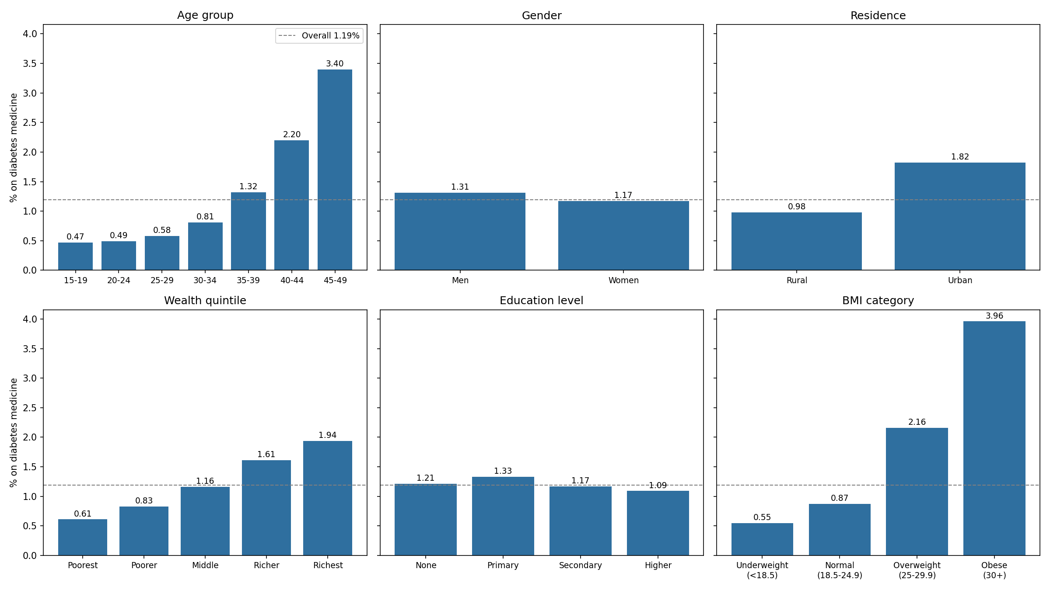
Figure 1: Share of adults on diabetes medicine across population groups
All panels share one scale; the dashed line marks the overall 1.19%. The steepest gradients are by age, BMI and wealth:
- Age: prevalence rises from 0.47% at 15–19 to 3.40% at 45–49, about seven times higher, with the climb steepening after 35.
- BMI: obese adults (BMI ≥ 30) are at 3.96%, seven times the underweight (0.55%).
- Wealth: the richest quintile is at 1.94%, three times the poorest (0.61%), rising at each step.
- Residence: urban 1.82% vs rural 0.98%.
- Gender: men 1.31% vs women 1.17%.
- Education: almost flat (1.09–1.33%), with no steady pattern.
- Hypertension: 5.10% among hypertensives vs 0.90% among others.
- Alcohol and tobacco: almost no difference (alcohol 1.28% vs 1.18%; tobacco 1.14% vs 1.19%).
States. Prevalence is highest in Puducherry (3.33%), Kerala (3.30%), Tamil Nadu (2.72%), Goa (2.68%) and Chandigarh (2.66%). It is lowest in Nagaland (0.43%), Rajasthan (0.55%), Jharkhand (0.62%), Chhattisgarh (0.65%) and Madhya Pradesh (0.72%). Because the outcome is medicine use, part of this gap may reflect better diagnosis and treatment access in the south, not only more disease.
Correlations with the outcome. Glucose has by far the strongest correlation (r = 0.28), followed by hypertension (0.10), age (0.08), BMI (0.08), BP (0.06), wealth (0.04) and urban residence (0.03). Education, gender, alcohol and tobacco are near zero (|r| < 0.01). These are simple linear correlations; a decision tree can also find threshold effects they miss, such as a risk that applies only above a certain age.

4. Model building (decision tree)
The final model is a pruned tree with 45 leaves. It identifies people on diabetes medicine with a test-set AUC of 0.80, and glucose, hypertension, age and BMI do almost all the work.
The data were split 70/30 into training (539,206 people) and test (231,089) sets, stratified so both keep the 1.19% share of diabetics. Three trees were built:
Table 9: Decision tree models compared
Model | Set-up | Depth | Leaves
A: Unpruned | Grown fully, no class weights (as in the course example) | 65 | 9,733
B: Tuned (final) | Balanced class weights; settings chosen by 5-fold cross-validation | 6 | 45
C: Tuned, no glucose | Model B's settings, glucose removed | 6 | —
Class imbalance. With only 1.19% positive, a tree that predicts "not diabetic" for everyone is 98.8% accurate but finds nobody. Models B and C therefore use balanced class weights, which make each missed diabetic count as much as about 83 false alarms. They are judged on sensitivity, specificity and AUC rather than accuracy.
Tuning. For model B, impurity measure (Gini or entropy), maximum depth (3–8) and minimum leaf size (100–1,000) were chosen by 5-fold stratified cross-validation on the training set alone, maximising AUC. The best combination was Gini, depth 6 and at least 1,000 people per leaf. The test set was kept untouched until final evaluation. Choosing settings by test-set accuracy, as in the course example, would overstate performance on new data.
What the tree uses. The first split is glucose at 145.5 mg/dL, close to the clinical threshold of 140. Below it, the tree splits on hypertension, then age (40.5 years) and BMI (about 26.5).
Table 10: Feature importance, models B and C
Feature | Importance: model B (with glucose) | Importance: model C (no glucose)
Glucose | 0.77 | —
Hypertension | 0.13 | 0.21
Age | 0.04 | 0.55
BMI | 0.04 | 0.10
Wealth score | 0.01 | 0.11
BP (systolic + diastolic) | 0.005 | 0.03
Education, urban, gender, alcohol, tobacco | < 0.01 combined | < 0.01 combined
Without glucose, age becomes the dominant predictor, followed by hypertension, wealth and BMI.
Highest-risk groups found by the tree (training data; base rate 1.19%):
Table 11: Highest-risk leaves identified by the tree
Leaf rule | People | % on medicine
Glucose > 242.5, age > 37.5, wealth score > −3.0 | 2,350 | 46.3
Glucose 200.5–242.5, age > 37.5, wealth score > −3.0 | 1,267 | 34.8
Glucose > 200.5, age ≤ 37.5, wealth score > −3.0 | 1,427 | 26.4
Glucose 170.5–200.5, age > 40.5, wealth score > 0.1 | 1,500 | 19.9
Glucose > 200.5, wealth score ≤ −3.0 | 1,330 | 18.0
Glucose 145.5–170.5, BMI > 20.5, age > 36.5, hypertensive | 1,222 | 13.1
Wealth appears even among people with very high glucose (above 200 mg/dL). Those in poorer households (wealth score ≤ −3.0) are far less likely to be on medicine (18.0%) than richer people at similar glucose levels (26–46%). This points to a treatment gap by wealth, discussed in Section 6.

5. Cross-validation
The tuned tree generalises well: its AUC is 0.82 on training data, 0.81 across cross-validation folds and 0.80 on the unseen test set. The unpruned tree memorises the training data and fails on new people.
Table 12: Training vs testing
Model | Data | Accuracy | Sensitivity | Specificity | Precision | AUC
A: Unpruned | Train | 1.000 | 1.000 | 1.000 | 1.000 | 1.000
A: Unpruned | Test | 0.978 | 0.171 | 0.988 | 0.143 | 0.579
B: Tuned (final) | Train | 0.875 | 0.657 | 0.878 | 0.061 | 0.816
B: Tuned (final) | Test | 0.874 | 0.636 | 0.877 | 0.058 | 0.797
C: No glucose | Train | 0.781 | 0.634 | 0.783 | 0.034 | 0.767
C: No glucose | Test | 0.780 | 0.606 | 0.782 | 0.032 | 0.746
Model A is perfect on training data but finds only 17% of diabetics in the test set (AUC 0.58, barely better than chance): classic overfitting. Model A's 97.8% test accuracy shows why accuracy misleads here; it comes almost entirely from correctly labelling non-diabetics. Model B loses only 0.02 AUC between training and test.
Stability across folds. Model B's validation AUC across the five folds was 0.801, 0.796, 0.813, 0.817 and 0.806 (mean 0.806, SD 0.008). The narrow spread means performance does not depend on a lucky split.
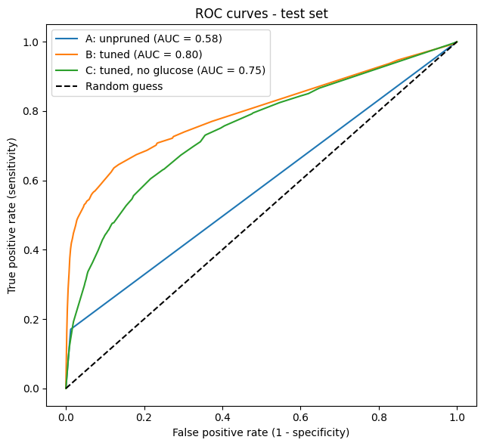
Figure 2: ROC curves on the test set for models A, B and C
Choosing a threshold. On the test set at the default 0.5 threshold, model B finds 1,745 of 2,743 people on medicine (sensitivity 63.6%) and correctly clears 87.7% of the rest. The cost is 28,086 false alarms, so only 5.8% of flagged people are on medicine. Moving the threshold trades these off:
Table 13: Model B performance at different classification thresholds
Threshold | Sensitivity | Specificity | Precision | % of people flagged
0.3 | 0.727 | 0.725 | 0.031 | 28.0
0.5 (default) | 0.636 | 0.877 | 0.058 | 12.9
0.7 | 0.523 | 0.955 | 0.123 | 5.0
0.9 | 0.419 | 0.986 | 0.266 | 1.9
For a screening programme, a low threshold suits a cheap follow-up test such as a fasting glucose check. A high threshold suits scarce resources, such as specialist referral.
Validation against "currently diabetic". Medicine use only captures diagnosed, treated diabetics. The model was therefore also checked against two other measures in the test set:
Table 14: Model performance against alternative measures of diabetes
Measure of diabetes | % positive | AUC model B | AUC model C (no glucose)
On diabetes medicine (training target) | 1.19 | 0.797 | 0.746
Self-reports "currently has diabetes" | 1.66 | 0.770 | 0.740
Told high blood glucose by a health professional | 1.86 | 0.834 | 0.788
The model holds up on both: it ranks people told they have high glucose even better (AUC 0.83) than the outcome it was trained on.
The hidden group. In the test set, 14,464 people (6.3%) had random glucose above 140 mg/dL but were not on medicine. That is 5.3 times the 2,743 who were on medicine. Model B flags 69.2% of them, and model C, without any blood test, flags 42.8%. A single random glucose reading is not a diagnosis, but this group is the natural target for confirmatory testing.

6. Inferences
Age, hypertension, obesity, wealth and urban residence are clearly linked to being on diabetes medicine. Gender shows only a small difference; education, alcohol and tobacco show none; and the genetic hypothesis cannot be tested with NFHS-5.
Each hypothesis was tested in two ways: by comparing the share on medicine across groups (Section 3), and with a chi-square test of whether the factor and diabetes are independent. With 770,295 people even tiny differences can be statistically significant, so the size of the difference matters more than the p-value. The decision tree's feature importance (Section 4) gives a second check.
Table 15: Hypothesis tests and verdicts
Hypothesis | Evidence (% on medicine) | Chi-square p-value | Verdict
Risk rises with age | 0.47% at 15–19 → 3.40% at 45–49 (7×) | < 0.001 | Supported
Hypertension and diabetes go together | 5.10% vs 0.90% (5.7×) | < 0.001 | Supported, strongest
Obesity raises risk | Obese 3.96% vs underweight 0.55% (7×) | < 0.001 | Supported
Wealthier people are at higher risk | Richest 1.94% vs poorest 0.61% (3×) | < 0.001 | Supported
Urban residents are at higher risk | 1.82% vs rural 0.98% (1.9×) | < 0.001 | Supported
Men are at higher risk than women | 1.31% vs 1.17% | < 0.001 | Weak: real but small
Education protects against diabetes | 1.09–1.33%, no steady pattern | < 0.001 | Not supported
Alcohol raises risk | 1.28% vs 1.18% | 0.13 | Not supported
Tobacco raises risk | 1.14% vs 1.19% | 0.21 | Not supported
Family history (genetics) raises risk | Not measured in NFHS-5 | — | Cannot be tested
Three results need care in interpretation:
- Education is statistically significant only because the sample is huge; the differences are tiny and the tree does not use it. Any small pattern probably reflects age, since younger people are both more educated and less often diabetic.
- Tobacco and alcohol show no difference, but the data are cross-sectional: people diagnosed with diabetes are often advised to quit, which could hide a real effect.
- Wealth and urban residence may reflect both lifestyle (diet, inactivity) and better access to diagnosis and medicine. Because the outcome is medicine use, the two cannot be separated here.

Lessons for policy
- Most high-glucose cases are untreated. For every person on medicine, about five more have random glucose above 140 mg/dL without treatment (Section 5). Screening, not only treatment, is the main gap.
- Screening can be targeted. Risk climbs steeply after age 35, and hypertensives are on diabetes medicine at nearly six times the rate of others, so diabetes testing fits naturally into hypertension care. A glucose-free version of the tree, using age, BMI, BP and wealth, still flags 43% of the untreated high-glucose group. Frontline health workers could use such a checklist to decide who needs a blood test.
- There is a treatment gap by wealth. Among people with glucose above 200 mg/dL, those from poorer households are much less likely to be on medicine (18%) than richer people (26–46%). Free diagnosis and medicine supply in poorer areas would address this.
- State differences partly reflect diagnosis. Southern states and union territories show the highest prevalence (Puducherry 3.33%, Kerala 3.30%), but because the outcome is medicine use, low figures in states such as Rajasthan (0.55%) may partly reflect under-diagnosis.
Limitations. The outcome captures only diagnosed, treated diabetes. Glucose is a single random (non-fasting) reading, not a diagnostic test. The data are cross-sectional, so associations are not causal. The sample covers ages 15–49 only, missing older adults, in whom diabetes is most common. All figures are unweighted, so they describe the surveyed sample; NFHS sampling weights would be needed for national estimates.

